### 

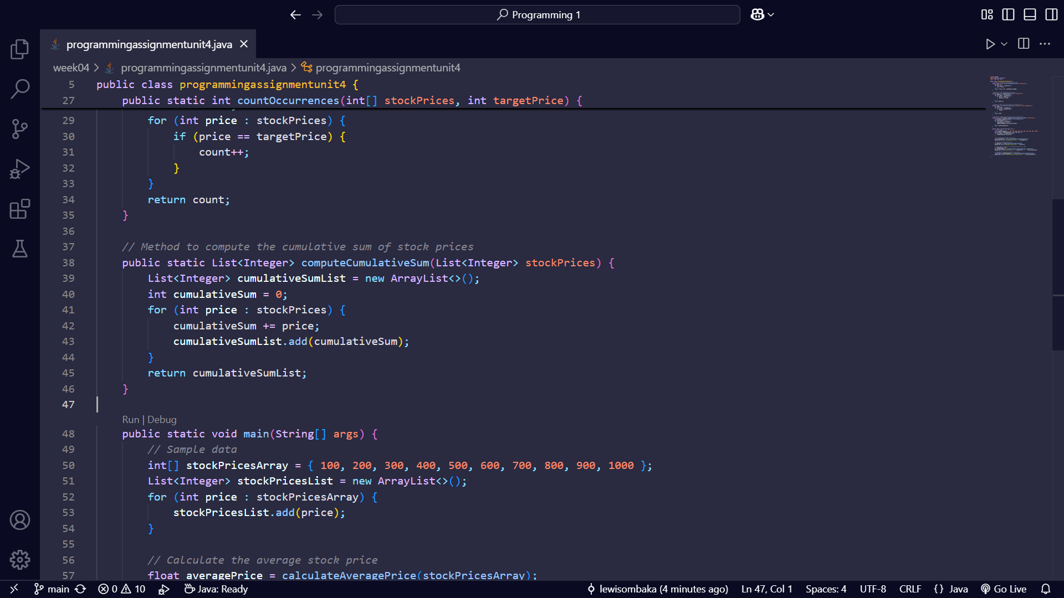

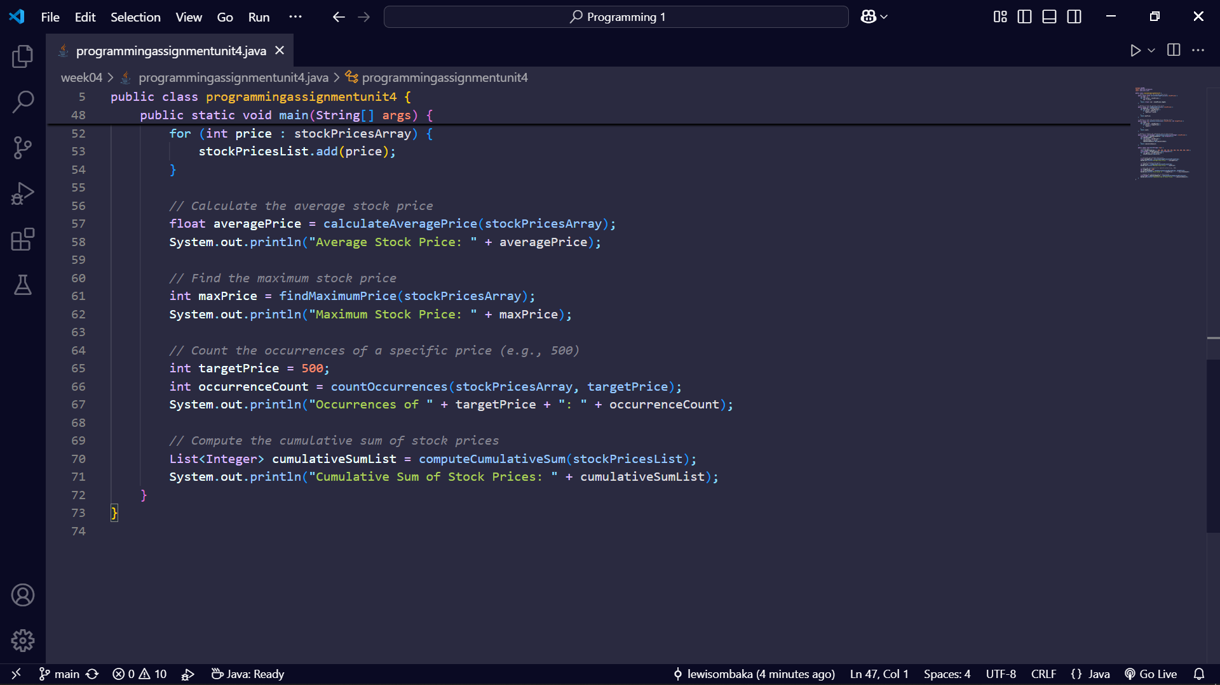

### **Explanation**

1. **Calculate the Average Stock Price:**
   * Method: calculateAveragePrice
   * This method takes an array of stock prices as input, calculates the sum of all prices, and returns the average by dividing the sum by the number of elements in the array.
2. **Find the Maximum Stock Price:**
   * Method: findMaximumPrice
   * This method iterates through the array of stock prices and finds the maximum price by comparing each element with the current maximum.
3. **Determine the Occurrence Count of a Specific Price:**
   * Method: countOccurrences
   * This method takes an array of stock prices and a target price as input. It counts and returns the number of times the target price occurs in the array.
4. **Compute the Cumulative Sum of Stock Prices:**
   * Method: computeCumulativeSum
   * This method takes an ArrayList of stock prices as input and returns a new ArrayList containing the cumulative sum of prices at each position.

### **Output**

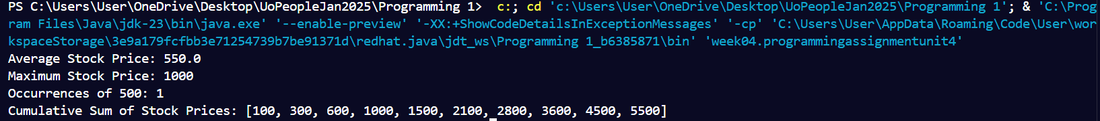

This output shows the average stock price, the maximum stock price, the occurrence count of a specific price, and the cumulative sum of the stock prices.